ACADIA CENTER APPLAUDS Massachusetts Governor Healey for Timely Executive Order Promoting Cheapest, Fastest-to-Deploy Clean Energy Resources, Inclusion of Supply, Storage, Grid, and Demand-Side Solutions to Drive Energy Affordability
*Region will enhance affordability and reliability with gigawatt-scale annual deployments *Demand-side flexibility solutions will help manage peaks, reduce infrastructure costs
*Portfolio of solutions vital to insulate against risk of fuel price shocks from global events
*Gas system investments must pass non-pipeline solutions screening, prove compatibility with least-cost, clean energy pathways for affordability and reliability

WINCHESTER, MA — Today, Massachusetts Governor Maura Healey and state energy officials announced a timely and important new Executive Order aimed at driving a coordinated, 15 gigawatt (GW) build-out of clean energy resources to meet the pressing affordability and reliability needs of the moment. Coming on the heels of continued hostility and intransigence on energy policy from the federal government, today’s action leans strongly into the substantial legal and policy authorities that states possess to shape their energy future and serve as a bulwark against federal backsliding. And critically, the Executive Order represents a compelling and effective portfolio of solutions to counter the continued misguided pressure campaign to double-down on the Commonwealth’s overreliance on natural gas with more interstate pipeline capacity. Acadia Center applauds the Healey-Driscoll Administration for standing strong against such counterproductive proposals and laying out a ten-year plan that can move the Commonwealth and region more decisively in the direction it needs to go. It is essential that the review of natural gas and oil storage capacity directed by the Executive Order scrutinize all existing and/or newly proposed fossil fuel resources for compatibility and compliance with legally mandated emission reduction pathways, including by applying robust non-pipeline/non-fuel solutions screening and maximizing contributions from demand-side flexibility.

Kyle Murray, Director, State Program Implementation at Acadia Center, said, “At a time when some states are backing off of climate commitments and falsely blaming renewables for rising prices, I am proud that Massachusetts stays grounded in reality. I applaud the Healey-Driscoll administration for doubling-down on a strategy that will actually deliver energy independence and affordability to the Commonwealth.”

Jamie Dickerson, Senior Director, Climate and Clean Energy Programs at Acadia Center, said, “Recent events unfolding in global energy markets demonstrate all too vividly how susceptible current fossil fuel-based energy systems are to price shock events and extreme volatility in fuel costs. Proposals such as developing new natural gas pipeline capacity will only do more to exacerbate the overreliance and overexposure New England ratepayers already face. The Healey-Driscoll Administration has wisely chosen to keep the focus where it needs to be: on promoting new clean electricity supply, new energy storage, new grid connections, and new demand-side flexibility measures, which – at the scale of 10+ gigawatts – can collectively deliver a clean energy pipeline to meet the reliability needs of the region at far lower cost.”

Acadia Center has previously shared a similar vision about building out a clean energy pipeline for the Northeast region, and the organization is grateful to see this framing mirrored in the Governor’s actions today. The scale of the build-out envisioned in today’s announcement – on the order of 1-2 GW per year for 10 years – would make important strides toward the level of deployment that will ultimately be needed for the region to meet its broader goals for least-cost emissions reductions and preserving reliability. Acadia Center’s prior analysis conducted with Clean Air Task Force (CATF) suggested the region would need to ramp up clean energy deployments toward an average of 4-5 GW of new clean energy per year over the coming two decades years.

Mounting evidence makes clear that the fossil fuel alternatives – including adding interstate natural gas pipeline capacity – would come at substantial added costs to ratepayers. Acadia Center recently released analysis breaking down why a new natural gas pipeline would in fact exacerbate rather than relieve energy affordability pressures, including based on the upward pressure on natural gas prices from greater exposure to international fossil fuel commodity markets, such as Liquefied Natural Gas (LNG) – see Figure 1 below. This dynamic has sadly become even more acute in recent weeks with the price of oil and natural gas rising substantially in response to the fuel supply chain disruptions in the Middle East (including the world’s single largest LNG facility completely offline in Qatar). Today’s overreliance on fossil fuels – New England spends some $75 billion dollars a year on energy and fuel, two thirds of which is spent on oil and gas from outside the region – will leave families and businesses exposed to these rising costs, but for the actions of policymakers to hasten the clean energy transition.

Figure 1. Rising Natural Gas Commodity Costs from Rising Exposure to Global LNG Market Forces
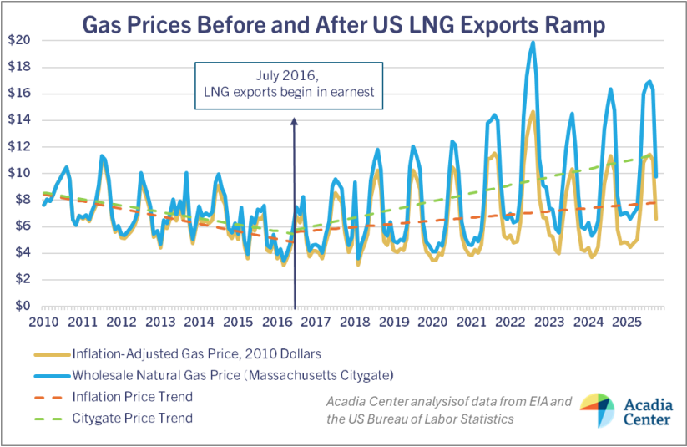

About the Executive Order
The Governor’s Executive Order contains a number of notable actions, including the following highlights:
Clean energy supply:

- The E.O. directs six and a half (6.5) gigawatts (GW) of new clean supply resources online, under contract, or under development by the end of 2035. This will include four new GW of solar and two-and-a-half GW of “new energy supply” into the New England power grid connecting to Massachusetts customers.
- The E.O. does not specify what will make up the 2.5 GW of new energy supply, but it presumably includes major contributions from northern New England renewable capacity unlocked by the Longer-Term Transmission Planning (LTTP) investment and forthcoming Northern Maine RFP, other potential interregional transmission investments stemming from the Northeast States Collaborative on Interregional Transmission, along with potential Canadian offshore wind supply pursuant to the recently enacted Memorandum of Understanding (MOU) with Nova Scotia. It is not clear how/whether other earlier-stage resources mentioned in the E.O., such as new nuclear energy, geothermal resources, or other “non-fossil thermal energy sources” might also fit into this category.
- The E.O. also establishes an additional goal of five GW of energy storage online or under development within Massachusetts by the end of 2035. This is a new/expanded storage target, on top of the 5 GW Section 83E requirements passed in the Climate Act of 2024.
Clean energy demand:
- To meet the overall 10 GW goal by 2035, the E.O. contemplates deploying three-and-a-half (3.5) new GW from demand management resources, such as virtual power plants, electric vehicle charging management, energy efficiency and demand response programs. This would constitute a major new demand-side portfolio, representing the ability to flex or shift more than 13% of the region’s summer and winter peaks forecast for the mid-2030s (e.g., net summer peak of 26,897 MW in 2034) – on top of existing demand management portfolios from Mass Save and Connected Solutions.
- This amount of flexible demand would also be substantially larger than estimates for growth in winter peak demand driven by heating electrification in Massachusetts (2,167 MW in 2034), demonstrating that electrification of space heating can be effectively managed when paired with smart demand management.
- This investment in flexible demand and virtual power plant capabilities will help directly target the costliest peak periods for the grid and broader energy systems each year. Recent analysis conducted for New York State identified that grid flexibility could reduce future peaks by more than 20% by 2040 – critical when many fixed infrastructure costs are driven by these peaks (e.g., each GW of peak demand is expected to drive $750m to $1.5b in transmission costs in New England).
Gas System Transition:
- The E.O. also directs Energy and Environmental Affairs (EEA) agencies to “review existing natural gas and oil storage capacity and utilization and coordinate with gas utilities, fossil fuel generation facilities, and other New England states to develop greater clarity on how the Everett Marine Terminal and other fuel storage assets may contribute to meeting regional energy supply needs and maintaining system reliability,” aligned with goals of meeting winter energy needs reliably and affordably.
- The E.O. also directs agencies to identify “identify whether additional, strategically located storage capacity or delivery capabilities could provide reliability and affordability benefits to all ratepayers and align with existing regulations.” Agencies are to propose recommendations to “ensure adequate natural gas and oil storage capacity and delivery capabilities that promote reliability and affordability, avoid unnecessary spending and adding charges to customer bills, and are aligned with existing regulations.”
- Acadia Center is pleased to see that solutions like new interstate gas pipeline capacity are off the table given the focus on avoiding unnecessary spending and adding charges to customer bills and the stated alignment with existing regulations, such as those in force pursuant to the Commonwealth’s legally binding emissions reductions requirements.
Grid Planning and Investment:
- Section 3 of the E.O. directs a wide range of positive grid-planning and distributed energy resource advancements, including:
  - Managing increased DG interconnection requests to maximize IRA tax credit eligibility;
  - Developing flexible interconnection programs; investigating the impact of and energy affordability solutions for large commercial customers such as data centers;
  - Expediting review of proposals for time-of-use (TOU) rates, DER, energy efficiency, and virtual power plants;
  - Proliferating models for community energy resilience hubs such as community microgrids; establishing clean energy ready zones; and
  - Examining pathways to lower the cost to ratepayers of transmission infrastructure necessary to meet energy needs in alignment with other states throughout the New England region (more to come on this subject from Acadia Center and partners soon!); among other actions.
Broad Support for Driving Affordability with Clean Energy
Recent polling work demonstrates strong and enduring public support for renewable energy and energy efficiency among New England voters, including accurate beliefs about many of the top underlying drivers of energy cost increases, including utility profits, natural gas infrastructure maintenance, and extreme weather. More information about Acadia Center’s analysis on energy cost drivers can be accessed here.
Acadia Center looks ahead with excitement to the opportunity to help the Commonwealth implement and make good on the provisions of this important executive action in keeping with the imperatives of climate, affordability, equity, safety and reliability, and beyond. The organization looks forward to working with members of the Healey-Driscoll Administration, the Legislature, and beyond.

